What
A short tutorial on how to quickly (under 1 minute) identify ALL source domains of a course page in Buzz. It also provides a test link, for each domain, that you can include in the ticket for the student to click/test with. During our session you can try out this technique and I’ll answer any questions you may have.

Why
This provides a fast, consistent and repeatable way of identifying the domain addresses a course page is dependent on. Use in cases where the course (or page) is NOT loading for the student. Clicking on each link (by the student) will identify whether the source is blocked by the schools filtering system.

How
Utilize the Buzz Gonkulator spreadsheet Tool (fortified with PowerQuery).

Steps
- Place of COPY of the Buzz Gonkulator spreadsheet file (which I shared with you) in a folder on your desktop.
- Navigate to the course page (in Buzz) that the student identified is not loading.
- Open the Google Chrome Developer Tool (Ctrl+Shift+I).
  - Select the Network Tab.
  - Reload/Refresh the Web page (in Buzz).
  - Right click on the results grid and save the HAR file to the desktop folder containing the Buzz Gonkulator spreadsheet file.
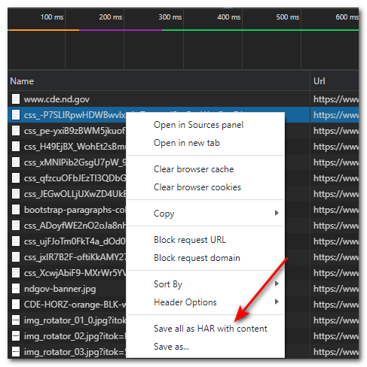
- Open the Buzz Gonkulator spreadsheet file in excel.
- Open the Data Source Settings dialog …
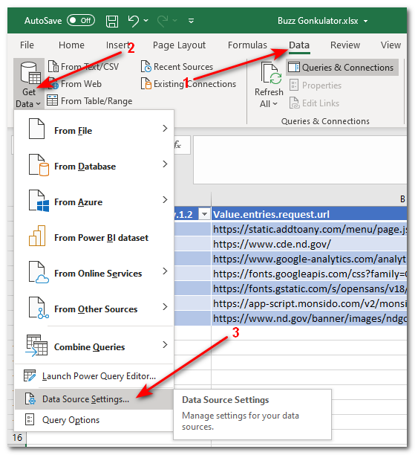
- Click the Change Source button, navigate to and select the HAR file you saved in the desktop folder containing the Buzz Gonkulator spreadsheet file, select it and then click the Close button.
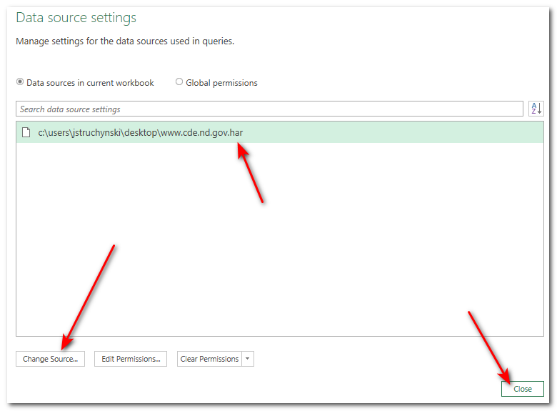
- Click the Refresh All button under the Data menu.
